Student Advocate's Office Caseworker Application

Fall 2019

412B Eshleman Hall | recruit@berkeleysao.org | http://advocate.berkeley.edu

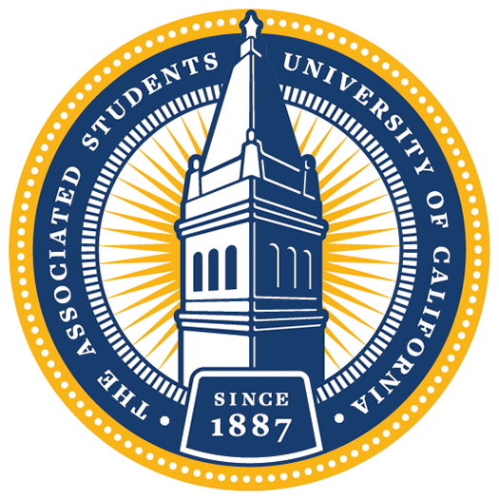

The Student Advocate’s Office (SAO) is a non-partisan, executive office of the ASUC. Effectively the campus public defender, we offer help, advice, and representation to any student or student group experiencing an issue with the University. We provide assistance for a broad variety of problems, including conduct allegations, grade disputes, enrollment issues, financial aid concerns, discrimination, and harassment. All assistance is free and confidential.
Each semester, we recruit a set of highly dedicated individuals to help resolve university disputes. If you are interested in applying for one of our caseworker positions, please submit your complete application by emailing this questionnaire along with a resumé to recruit@berkeleysao.org by noon on Wednesday, September 11th.
**Please read this document completely and carefully!**
Final applications should be submitted as a single PDF document with the questionnaire and your resume. (You can use an online PDF combiner to put the documents together).
By submitting an application, you are committing to the following if selected:
- Attending the Meet SAO event from 7 - 9 pm on Friday, September 13th. This is a chance to learn even more about the office and the caseworkers in it, prior to interviewing.
- One 30 minute interview on Saturday, September 14th or Sunday, September 15th.

Caseworker Expectations:
- Attend general meetings every Monday from 8 - 10pm
- Participate in new hire training and division-specific training
- Attend 4 hours of office hours every week
- Complete casework in a timely manner
- Actively participate in policy projects
*At least 7 - 9 hours dedicated to SAO per week

If you have any questions, feel free to stop by our office between 10am - 5pm Monday through Friday or email us at recruit@berkeleysao.org. Applicants are strongly encouraged to attend one of the information sessions in the ASUC Senate Chambers on the 5th floor of Eshleman Hall:

Thursday, September 5th at 8pm
Tuesday, September 10th at 9pm

Questionnaire

Name:

Preferred Name:

Pronouns (e.g. she/her/hers):
Email Address:
Phone Number:
(Intended) Graduation Date:
(Intended) Major(s)/Minor(s):
Have you applied for SAO before? If so, when?
What other commitments or potential commitments will you have this semester (estimated hours per week)?
How did you hear about SAO?

Please tell us why you want to be a part of the Student Advocate’s Office (300 words or fewer).

Explain how the skills you gained through one or two of the experiences on your resume would make you an effective caseworker in the Student Advocate’s Office (300 words or fewer).

Oski Bear is a student who was awarded a one-time grant of $1,000 in rental assistance through the SAO Rental Assistance Fund. After receiving the award, Oski reached out to you to explain that she was also unable to afford food for the entire month. Compose an outreach email to Oski outlining two resources that may be available to her. (Hint: You may need to do some online research to answer this!)

SAO is composed of four divisions: Financial Aid, Academic, Conduct, and Grievance. Please rank your preferences for which division you would like to work in (1 is most preferred, 4 is least). Please note that you will be able to rerank your preferences if you are selected to attend Meet SAO:
FINANCIAL AID |  | The Financial Aid Division assists students with financial aid issues, SHIP waiver processes, housing problems, administrative appeals, and billing and payment procedures. Financial Aid Division caseworkers will frequently interact with campus administrators to support and advise their clients on topics ranging from problems with the disbursement of aid to filing an appeal for designation as financially independent. Additionally, caseworkers will work on reforming campus policy to tackle broad challenges, like housing and food insecurity, in collaboration with various campus partners. Through casework and policy projects, the Financial Aid Division works to ensure that all students have the financial resources and support they need to perform as both a student and member of the Cal community.
ACADEMIC |  | The Academic Division assists students with academic-related issues, including grade disputes, enrollment, withdrawal, faculty-student relations, graduation, academic appeals, and probation/dismissal. The Academic Division works to ensure the implementation of equitable and transparent academic policies that improve the learning experiences of undergraduate and graduate students alike. Academic policy projects provide caseworkers with the opportunity to work on issues that affect all UC Berkeley students, and have included altering University policy, lobbying for the creation of new minors, and connecting students with relevant resources.
CONDUCT |  | The Conduct Division assists students who are accused of violating the Student Code of Conduct and other campus policies. Conduct caseworkers help students represent themselves at every stage of the conduct process by explaining the conduct process, helping students prepare for meetings and hearings, assisting students in gathering and organizing evidence, accompanying students to meetings and hearings, and helping students write appeals. Cases include: residential hall violations, academic misconduct, alcohol violations, theft, sexual violence and harassment, and physical violence cases. Conduct caseworkers work to ensure students’ rights and due process are upheld throughout the conduct process. Conduct policy includes advocating for the incorporation of restorative justice into adjudication processes, creating workshops on students’ rights, and reviewing revisions to the Student Code of Conduct.
GRIEVANCE |  | The Grievance Division advocates for students seeking complaint resolution – whether informal and formal. Common cases include denial of disability accommodations, discrimination on the basis of background or identity, harassment, or hate crimes. In addition, this division supports survivors of sexual violence who are seeking a confidential space to navigate their reporting options. Grievance also takes on cases that don't fit neatly into any other division's scope, including housing, consent education, and medical withdrawal. Grievance policy focuses on concerns such as disability compliance, the sexual violence adjudication process, and the formal grievance process, and its caseworkers work to revise these processes, promote equity in the student experience, and codify "best practices" for departments across the University.

How strong are these preferences? (100 words or fewer)

Don’t forget to attach a resume along with your completed questionnaire.
APPLICATIONS ARE DUE ON WEDNESDAY, SEPTEMBER 11th AT NOON – PLEASE EMAIL COMPLETED APPLICATIONS TO RECRUIT@BERKELEYSAO.ORG
GOOD LUCK!

Further explanations of the scope of each division can be found at http://advocate.berkeley.edu

