The Student Advocate's Office Caseworker Application

Spring 2019

412B Eshleman Hall | recruit@berkeleysao.org | http://advocate.berkeley.edu

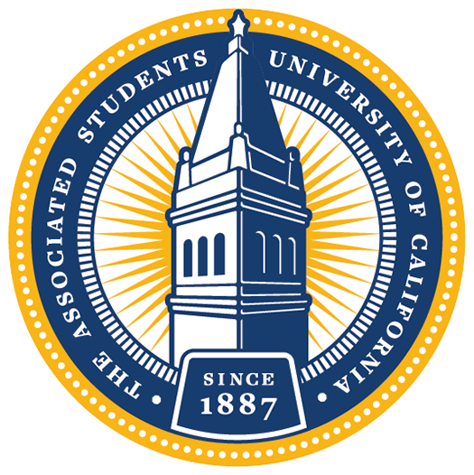

The Student Advocate’s Office (SAO) is a non-partisan, executive office of the ASUC. Effectively the campus public defender, we offer help, advice, and representation to any student or student group involved in a dispute with the University. We provide assistance for a broad variety of problems, including conduct allegations, grade disputes, enrollment issues, financial aid concerns, discrimination, and harassment. All assistance is free and confidential.
Each semester, we recruit a set of highly dedicated individuals to help resolve university disputes. If you are interested in applying for one of our caseworker positions, please submit your complete application by emailing this questionnaire along with a resume and cover letter to recruit@berkeleysao.org by NOON on Wednesday, February 6th, 2019.
Please read this document completely and carefully!
By submitting an application, you are committing to the following if selected:
- Attend Meet SAO from 6-8pm on Friday, February 8th. This is a chance to learn more about the work we do and meet the people in the office prior to interviewing.
- Attend one 30-minute interview on Saturday, February 9th or Sunday, February 10th.
- Attend New Caseworker Training on Sunday, February 24th.
- Attend General Meetings every Monday from 8-10pm.
- Complete 4 mandatory office hours every week.
- Take on your own casework.
- Collaborate on policy projects.
- Dedicate a total of at least 7-9 hours to SAO per week.

Final applications should be submitted as a SINGLE PDF document and include the following:

- Cover letter detailing your interest in the position
- Resume
- Completed questionnaire below

If you have any questions, feel free to stop by our office or email us at recruit@berkeleysao.org. Applicants are strongly encouraged to attend one of the information sessions:

Thursday, January 31st at 6pm in the Senate Chambers (5th floor of Eshleman)
Tuesday, February 5th at 8pm in the Senate Chambers

Find more information about these events on our organization’s Facebook page!

Questionnaire:

- Name:
- Preferred Pronouns (e.g. she/her/hers):
- Email Address:
- Phone Number:
- (Intended) Graduation Date:
- (Intended) Major(s):
- (Intended) Minor(s):
- Have you applied for SAO before?
- Did you attend an info session this year?

- Are you applying for or do you work for any other ASUC offices?

- What other commitments will you have this semester (estimated hours per week)?

- How did you hear about SAO?

- SAO is comprised of four divisions: Financial Aid, Academic, Conduct, and Grievance. Please rank your preferences for which division you would like to work in (1 is most preferable, 4 is least). NOTE: you will have an option to re-rank your choices after Meet SAO:
FINANCIAL AID |  | The Financial Aid Division assists students with financial aid issues, SHIP waiver  processes, in-state residency appeals, and billing and payment procedures. Financial Aid Division caseworkers will frequently interact with campus administrators to represent and advise their clients on topics ranging from problems with the disbursement of aid to filing an appeal for designation as financially independent. Additionally, caseworkers will work on reforming campus policy to tackle broad challenges, like housing insecurity, in collaboration with various campus partners. Through casework and policy projects, the Financial Aid Division provides services that seek to create equitable access to education and ensure students are not left behind in navigating university procedures.
ACADEMIC |  | The Academic Division assists students with a wide variety of academic affairs including grade disputes, testing accommodations, enrollment and withdrawal, faculty-student relations, academic appeals, and probation and dismissal. Navigating the University bureaucracy to help clients with academic issues requires persistence, excellent attention to detail, and creative problem-solving skills. In addition to providing guidance and personally advocating on behalf of students with academic disputes, the Academic Division works to ensure the implementation of just academic policies to make our University more accessible and egalitarian and to improve the learning experiences of undergraduate and graduate students alike.
CONDUCT |  | The Conduct Division's role is to ensure due process by maintaining and fighting for the rights of the accused. This division specifically assists students alleged of violating the Student Code of Conduct. A Conduct Caseworker helps their clients through every stage of the conduct process and University procedures, from communicating with the Center for Student Conduct to attending clients' conduct hearings, and through the appeal process. The Conduct Division is a team of passionate caseworkers dedicated to defending UC Berkeley students and upholding their rights.
GRIEVANCE |  | The Grievance Division of SAO advocates for students who have encountered harassment or discrimination from students, faculty, or staff. Discrimination can take many forms - sexual assault, hate crimes, denial of disability accommodations, or simply unfair treatment on the basis of a student's personality or background. Grievance also takes the cases and policy projects that don't fit cleanly into any other division's scope, such as issues with housing, consent education, and helping to codify "best practices" for several departments within the University.  Throughout the course of a typical case, a caseworker might meet with faculty in order to mediate an informal resolution, meet with the Office for the Prevention of Harassment and Discrimination to report an instance of discrimination or harassment, or, if all other methods fail, file a formal grievance to initiate a formal investigation into the incident.

- How strong are these preferences? Why? (150 words or fewer)

- Please briefly describe why students’ rights are important to you. What student issues do you feel are pervasive on campus today? (400 words or fewer)

- Jane Doe has been accused of plagiarism on her final paper for her introductory history course. Her professor has stated that as a result of this academic integrity violation she will not only receive an F on the paper, but will also fail the course. Jane believes that she has been unfairly accused of academic dishonesty and has now come to the Student Advocate’s Office for help. Compose an email to her professor requesting a meeting to discuss a potential informal resolution for this matter.

Please attach a resume and cover letter along with this completed questionnaire in a single PDF document.
APPLICATIONS ARE DUE ON WEDNESDAY, FEBRUARY 6TH BY NOON – PLEASE EMAIL COMPLETED APPLICATIONS TO recruit@berkeleysao.org
GOOD LUCK!

Further explanations of divisional roles, responsibilities, and jurisdiction are available at http://advocate.berkeley.edu

