Student Advocate's Office Caseworker Application

Fall 2018

412B Eshleman Hall | recruit@berkeleysao.org | http://advocate.berkeley.edu

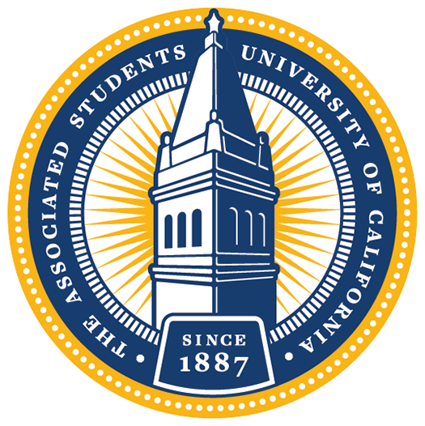

The Student Advocate’s Office (SAO) is a non-partisan, executive office of the ASUC. Effectively the campus public defender, we offer help, advice, and representation to any student or student group involved in a dispute with the University. We provide assistance for a broad variety of problems, including conduct allegations, grade disputes, enrollment issues, financial aid concerns, discrimination, and harassment. All assistance is free and confidential.
Each semester, we recruit a set of highly dedicated individuals to help resolve university disputes. If you are interested in applying for one of our caseworker positions, please submit your complete application by emailing this questionnaire along with a resumé and cover letter to recruit@berkeleysao.org by 2 PM on Wednesday, September 5th, 2018.
**Please read this document completely and carefully!**
By submitting an application, you are committing to the following if selected:
- Attending the Meet SAO event from 7-9 pm on Friday, September 7th. This is a chance to learn even more about the office and the caseworkers in it, prior to interviewing.
- One 30 minute interview during the weekend of September 8th-9th.
- General and Caseworker Training on September 16th.
- 2 hours of general meetings (every Monday at 8:00 pm).
- 4 mandatory office hours every week.
- Policy projects.
- Casework services.
- A total of at least 7-9 hours dedicated to SAO per week.

Final applications should be submitted in PDF format and include the following in ONE document:

- Cover letter detailing your interest in the position
- Résumé
- Completed Questionnaire below

In addition, please describe your availability for an interview during the weekend of September 8th-9th in the body of your email.

If you have any questions, feel free to stop by our office or email us at help@berkeleysao.org. Applicants are strongly encouraged to attend one of the information sessions:

8:00PM on Thursday, August 30th, Location TBA
8:00PM on Tuesday, September 4th in the 5th floor Eshleman ASUC Senate Chambers

Find more information about these events on our organization’s Facebook page!

Questionnaire:

Name:
Email Address:
Phone No:
(Intended) Graduation Date:
(Intended) Major(s):
(Intended) Minor(s):
Have you applied for SAO before?
Did you attend an info session this year?

Are you applying for or do you work for any other ASUC offices?

What other commitments will you have this semester (estimated hours per week)?

How did you hear about SAO?

SAO is comprised of four divisions: Financial Aid, Academic, Conduct, and Grievance. Please rank your preferences for which division you would like to work in (1 is most preferable, 4 is least). NOTE: you will have an option to re-rank your choices after Meet SAO:
FINANCIAL AID |  | The Financial Aid Division assists students with financial aid issues, SHIP waiver  processes, in-state residency appeals, and billing and payment procedures. Financial Aid Division caseworkers will frequently interact with campus administrators to represent and advise their clients on topics ranging from problems with the disbursement of aid to filing an appeal for designation as financially independent. Additionally, caseworkers will work on reforming campus policy to tackle broad challenges, like housing insecurity, in collaboration with various campus partners. Through casework and policy projects, the Financial Aid Division provides services that seek to create equitable access to education and ensure students are not left behind in navigating university procedures.
ACADEMIC |  | The Academic Division assists students with a wide variety of academic affairs including grade disputes, testing accommodations, enrollment and withdrawal, faculty-student relations, academic appeals, and probation and dismissal. Navigating the University bureaucracy to help clients with academic issues requires persistence, excellent attention to detail, and creative problem-solving skills. In addition to providing guidance and personally advocating on behalf of students with academic disputes, the Academic Division works to ensure the implementation of just academic policies to make our University more accessible and egalitarian and to improve the learning experiences of undergraduate and graduate students alike.
CONDUCT |  | The Conduct Division's role is to ensure due process by maintaining and fighting for the rights of the accused. This division specifically assists students alleged of violating the Student Code of Conduct. A Conduct Caseworker helps their clients through every stage of the conduct process and University procedures, from communicating with the Center for Student Conduct to attending clients' conduct hearings, and through the appeal process. The Conduct Division is a team of passionate caseworkers dedicated to defending UC Berkeley students and upholding their rights.
GRIEVANCE |  | The Grievance Division of SAO advocates for students who have encountered harassment or discrimination from students, faculty, or staff at UC Berkeley. Discrimination can take many forms - sexual assault, hate crimes, denial of disability accommodations, or simply unfair treatment on the basis of a student's personality or background. Grievance also takes the cases and policy projects that don't fit cleanly into any other division's scope, such as issues with housing, consent education, and helping to codify "best practices" for several departments within the University.  Throughout the course of a typical case, a caseworker might meet with faculty in order to mediate an informal resolution; OPHD (the Office for the Prevention of Harassment and Discrimination) to report an instance of discrimination or harassment; or, if all other methods fail, to file a formal grievance to initiate a formal investigation into the incident.

How strong are these preferences? Why? (150 words or fewer)

Please briefly describe why students’ rights are important to you. What student issues do you feel are pervasive on campus today? (400 words or fewer)

Sophie Bandarkar has been accused of plagiarism on her final paper for her introductory history course. Her professor has stated that as a result of this Academic Integrity violation, she will not only receive an F on the paper, but will also fail the course. Sophie believes that she has been unfairly accused of Academic Dishonesty and has now come to the Student Advocate’s Office for help. Compose an email to her professor, requesting a meeting to discuss a potential informal resolution for this matter.

Please attach a résumé and cover letter along with your completed questionnaire.
APPLICATIONS ARE DUE ON WEDNESDAY, SEPTEMBER 5TH BY 2PM– PLEASE EMAIL COMPLETED APPLICATIONS TO RECRUIT@BERKELEYSAO.ORG
GOOD LUCK!

Further explanations of divisional roles, responsibilities, and jurisdiction are available at http://advocate.berkeley.edu

